Word template: automatically add page to get even pages in document

Word function to add page

Peter Geelen (Quest For Security)

peter@questforsecurity.be

Abstract

This document is demo template to show how you can use a Word function to add a page, to make sure the document has always EVEN pages in total

Contents

Interesting Shortcuts and settings 3

In-document editing 3

Show/Hide Formatting controls (shortcut CTRL+8) 3

Update Functions – shortcut key F9 3

Show/hide function codes (ALT+F9) 3

Page Break (CTRL+ENTER) 3

Printing 4

Header 1 5

Header 1.1 5

Random text with Lorem function 5

Header 2 (Add or remove this header to make even or odd page doc) 6

Header 2.2 6

Random text with random function 6

Before Last page (Must be odd page) 7

Procedure 7

Explanation of code 7

Code section 7

Last page (must be on even Page) 8

References 8

Random and Lorem Ipsum random function 8

Add even page to uneven document 8

# Interesting Shortcuts and settings

## In-document editing

### Show/Hide Formatting controls (shortcut CTRL+8)

Use CTRL+8 to hide or show formatting symbolx

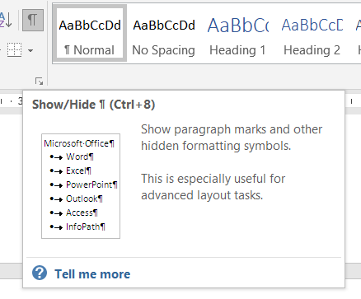

### Update Functions – shortcut key F9

Select the section to update

* Select Eg TOC
* Hit F9

If you want to update the entire document

* Select all (ctrl+a)
* Then hit F9

### Show/hide function codes (ALT+F9)

Use the <ALT+F9> shortcut to show or hide the word functions

### Page Break (CTRL+ENTER)

To add a page break (manually), use the CTRL+ENTER short cut

## Printing

Make sure to update the calculation functions when printing. You can set this option in the Word options.

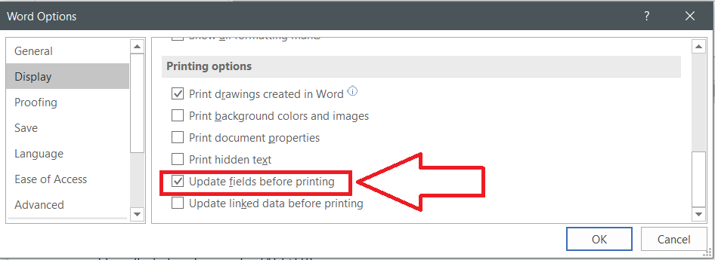

# Header 1

“Heading 1” function paragraph properties to add a page break before the paragraph.

## Header 1.1

= lorem(2,2)

### Random text with Lorem function

Lorem ipsum dolor sit amet, consectetuer adipiscing elit. Maecenas porttitor congue massa.

Fusce posuere, magna sed pulvinar ultricies, purus lectus malesuada libero, sit amet commodo magna eros quis urna. Nunc viverra imperdiet enim.

# Header 2 (Add or remove this header to make even or odd page doc)

## Header 2.2

= rand(2,2)

### Random text with random function

Video provides a powerful way to help you prove your point. When you click Online Video, you can paste in the embed code for the video you want to add.

You can also type a keyword to search online for the video that best fits your document. To make your document look professionally produced, Word provides header, footer, cover page, and text box designs that complement each other.

# Before Last page (Must be odd page)

## Procedure

Source: <https://wordmvp.com/FAQs/TblsFldsFms/InsEvnPgEndChap.htm>

**Code to use in this TEMPLATE document, to add a page BEFORE the last (not ON the last):**

**{** IF**{** =MOD(**{** PAGE \* Arabic **}**,2)**}**= 0 " " "Last page is odd, so adding break.**[page break]**" **}**

**Where [PAGE BREAK] must be replaced with CTRL+ENTER.**

## Explanation of code

The page number of the before-last page is checked to be un-even. (So last page must be even.)

To check for uneven, used the modulo function and check = 1 (uneven) or 0 (=even)

Then use the IF for adding action:

* First option, if = true
* Second option if = false

If before-last is uneven, then add message “Last page is odd, so adding break.” then add a page break.

## Code section

Start hitting <alt+F9> to show the codes.

Start with 3x <CTRL+F9> (that should create a function section like {{{}}}, see sample below

You can show the code above and below by typing ALT+F9

<active code on line below this one>

Page 7

Modulo : 1

WARNING: the modulo function is region dependent, so you might need to replace the ‘;’ with ‘,’ depending the digital number formats. (FYI: Doc created using Belgian-NL region format.)

This page odd, so last page even, do Nothing.

# Last page (must be on even Page)

## References

### Random and Lorem Ipsum random function

<https://support.microsoft.com/en-us/help/212251/how-to-insert-sample-text-into-a-document-in-word>

## Add even page to uneven document

<https://wordmvp.com/FAQs/TblsFldsFms/InsEvnPgEndChap.htm>

|  |
| --- |
| PAGE NUMBER: 8  MUST BE EVEN |